Irish Squash – Club Survey 2024
No. | Club
1 | West Wood, Leopardstown
2 | Killenaule Squash Clun
3 | Thurles
4 | Loughrea
5 | Ballyshannon Squash club
6 | ALSAA Squash Club
7 | Nenagh Squash Club
8 | Highfield Squash
9 | Ennis CBS Squash Club, Ennis, Co Clare
10 | Cloneen Squash Club
11 | Sunday's Well Squash Club (Cork)
12 | Curragh Squash Club
13 | Glenville Cork
14 | Arklow Squash Club
15 | Ballynafeigh tennis and squash club
16 | Dunhill Squash Club
17 | LCC Squash
18 | In4Squash
19 | University of Galway
20 | Westport
21 | Tullamore Squash Club
22 | Mid Ulster Squash Club
23 | Ballymena Squash Club
24 | Claremorris
25 | old belvedere
26 | Clomantagh
27 | Ballypatrick sports centre
28 | St Patrick’s Squash Club
29 | Fitzwilliam Lawn Tennis Club
30 | Ballina Stephenites Squash Clib
31 | Queens University Belfast Squash Club
32 | DUSRC (Trinity Squash)
33 | Foyle squash
34 | Rathnure Squash Club
35 | Galway Lawn Tennis Club
36 | Limerick Lawn Tennis Club
37 | Lisburn Racquets
38 | Celtic Squash Club Waterford
39 | Ballinrobe
40 | Ballyragget
41 | RCSI Squash
42 | Carlow lawn tennis club
43 | Athlone Squash Club
44 | Ballyearl
45 | Sligo Tennis Club
46 | kilkenny city squash club
47 | Piltown Squash Club
48 | Kilbrin
49 | Galmoy
50 | Clarecastle Squash Club
51 | South Lake/Banbridge
52 | Ballyfermot Sports Complex
53 | Killarney Squash Club
54 | Windsor LTC
55 | Mount Pleasant
56 | Sutton LTC
57 | Bangor Castle Squash Club
58 | Belfast Boat Club

Overall Summary
- 58 Clubs Responded (Only affiliated clubs asked)
- 11 NI Clubs vs 47 ROI Clubs

Membership
National Numbers
- Overall playing numbers up 17% to 5434
- Men up 12% to 3225
- Ladies up 19% to 1050
- Juniors up 34% to 1159
Provincial Numbers
Overall, every number in every province increased, astonishingly. Ulster the real highlight with minimum 50% growth in all categories and an amazing 300% in women. Shows the immense work and ROI from Will’s work up there.
Ulster
- Ulster up 107% overall.
- Females up 300%
- Juniors up 155%
- Males up 63%

Connacht
- Connacht up 5% overall
- Minor increases across all men, women and juniors

Leinster
- Leinster up 10% overall
- Juniors up 31%

Munster
- Munster up 14% overall
- Juniors up 27%
- Men up 15%

Juniors
- 29 clubs run junior programmes (48% of clubs)
- 58% of clubs who don’t have a junior programme intend to set one up
- Most popular junior programmes/initiatives are simply junior coaching (some free, some paid). 64% of clubs who have junior programmes listed coaching as the junior initiatives they run
- Just 6 clubs (19%) run camps and/or mention “fun” for kids
- 6 clubs (19%) give 8+ hours coaching p/w to junior initiatives (1 Ulster, 3 Leinster, 1 Munster, 1 Connacht).
- Conversely, 12 clubs (38%) who have junior programmes provide less than 2 hours of coaching p/w
- 70% of clubs who run junior programmes gave a 4 or 5 rating (max 5) to how effective their junior programmes have been.
Table 1 – Key supports requested to support junior programmes
Support Request *key selected ones* | Total Clubs Requesting This | Percentage
Introducing squash into schools | 7 | 12%
Additional Coaches | 17 | 28%
Provide additional equipment | 16 | 26%
General Guidance & Support on setting up Junior Programmes and Running of Junior Initiatives | 8 | 13%

Coaching
- 25 clubs (41%) have 3 or more qualified coaches, while 30 (50%) have 1 or no qualified coaches.
- 8 clubs have no internal qualified coaches and have no access to external qualified coaches
- 27 clubs say that their coaches provide 0-2 hours coaching p/w, while just 9 clubs have 10+ hours coaching p/w
- Clear that we need to provide additional coaches and/or coaching access to clubs

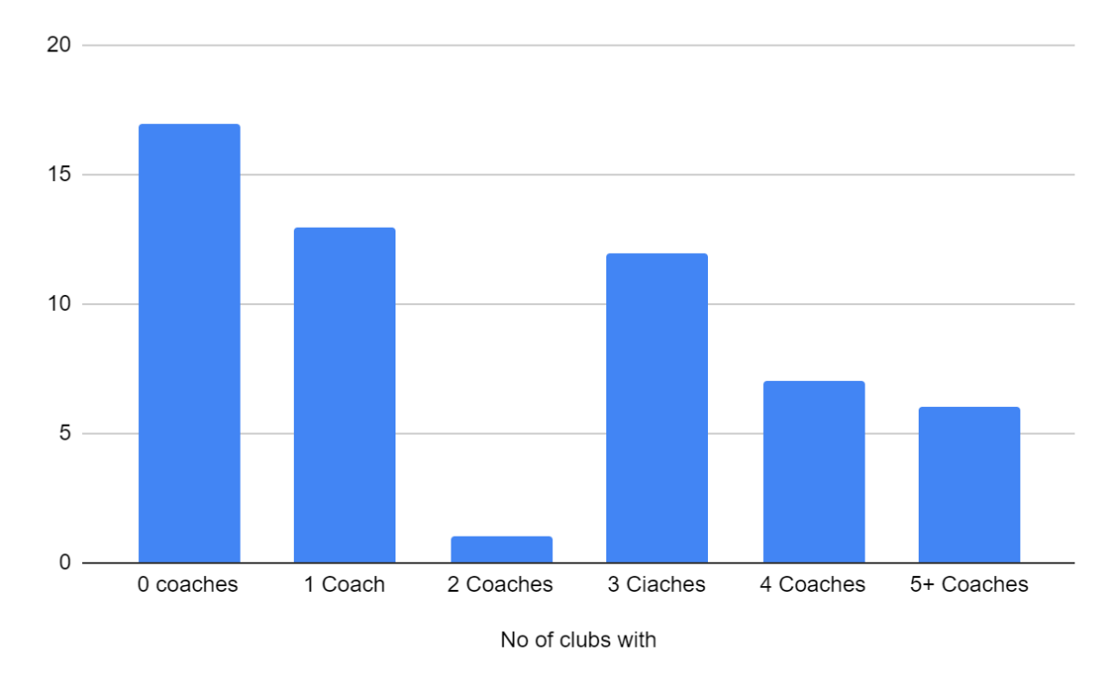
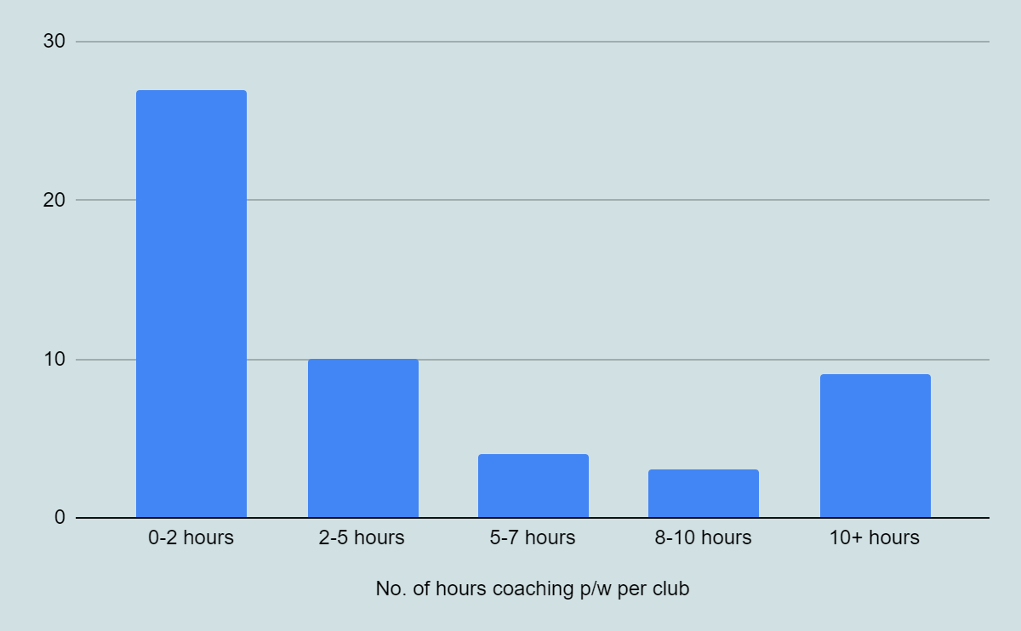
Inclusivity / WIS
- Less than 50% of clubs (24/60 – 40%) have club inclusion initiatives in place.
- For those that do have initiatives, WIS, Open nights and open-door policy are most common.
- Lack of Awareness or Interest (34 responses) and Lack of Targeted programmes (27 responses) are considered the biggest barriers to inclusion.
- 70% of all clubs said they would like to participate in Irish-Squash led D&I training and/or workshops
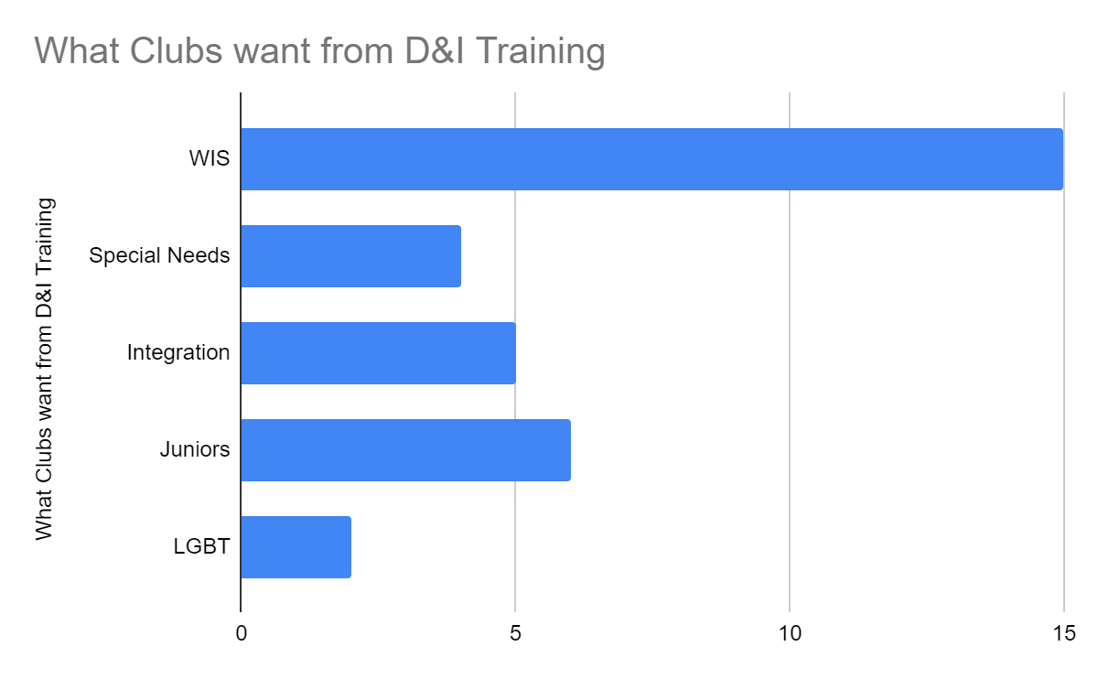
- 28% of clubs have WIS programmes
- Of those clubs that have WIS programmes, over 75% of them use “women only” nights and/or leagues/coaching. However, these initiatives are not very effective, with just 33% of clubs saying they are effective.
- 20 (of 43) who don’t have WIS programmes, would like to introduce some.
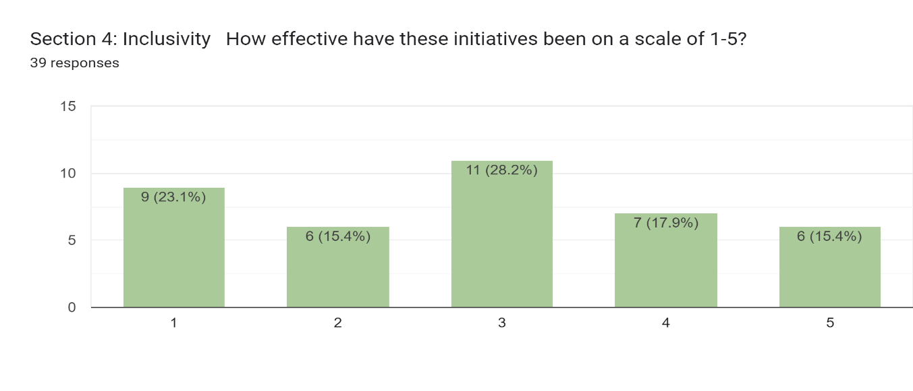
- The main supports requested from clubs to support WIS programmes can be seen below
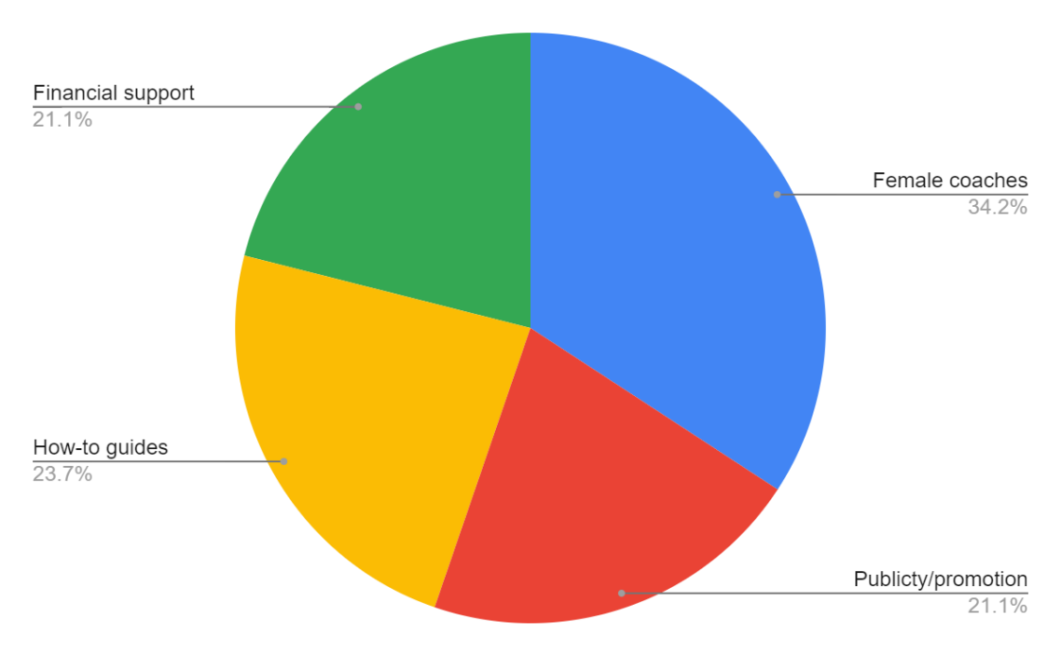
Social Media
- Over 91% of club are active on social media
- Facebook is by far the most popular club social media. Followed by Instagram. It also provides the most engagements for clubs
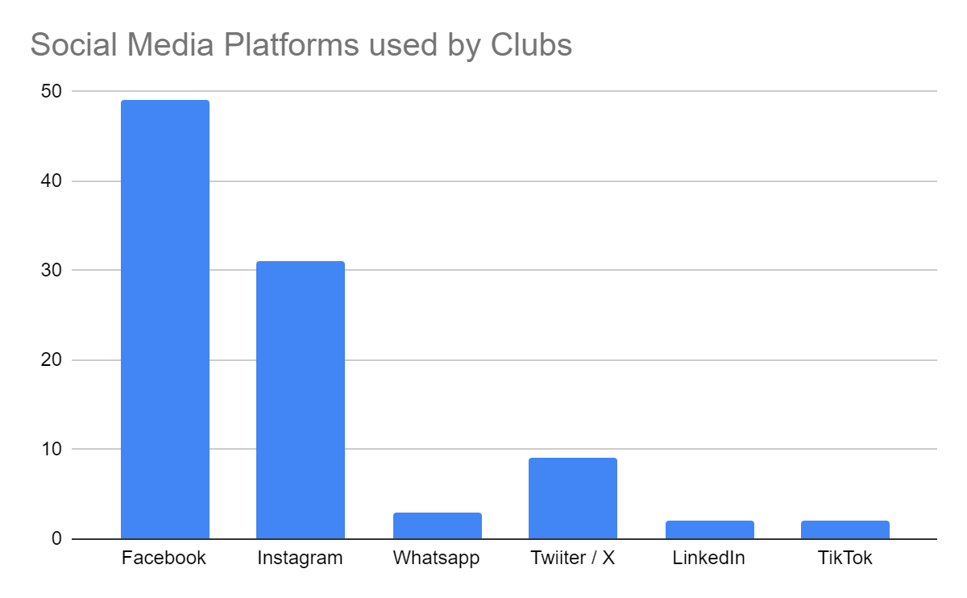
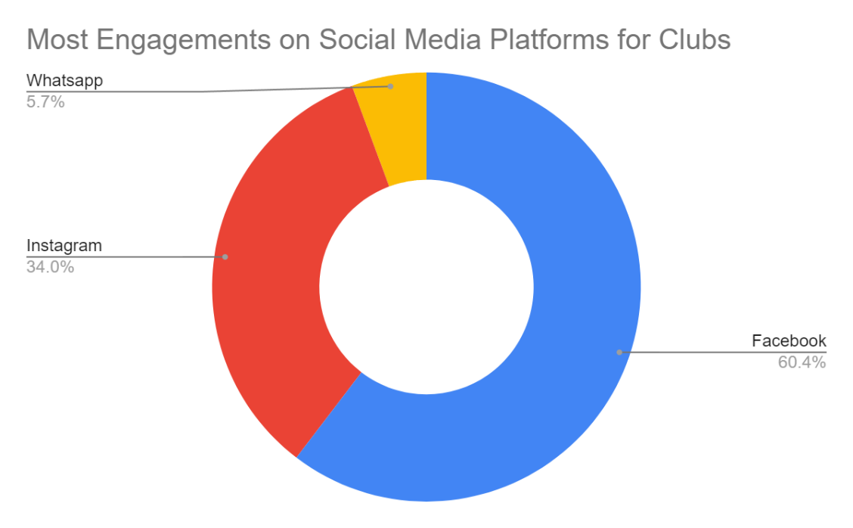
- Clubs would love some training and more re-sharing of their content. How-to-guides on best practices are also requested
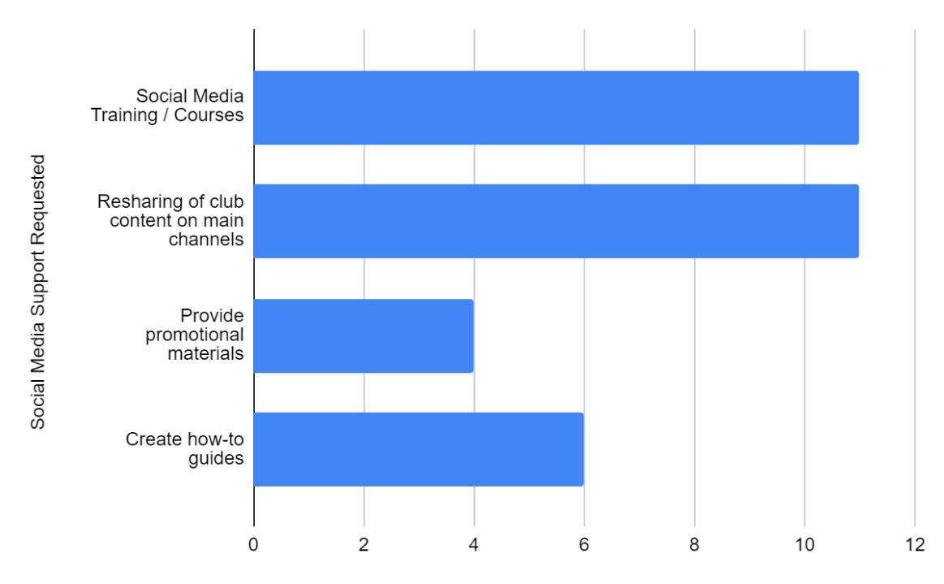

Facilities
- 65% of clubs are palling to carry out maintenance works in the next 12 months.
- Almost all the proposed maintenance works revolve around court refurbishment (Painting walls, installing court lighting, re-sanding floors etc)
- 43% of clubs are upgrading works in the next 12 months (capital works).
- These works include Coffee docks/stations, plumbing overhauls, changing room upgrades and new roofing.
- 55% of clubs are planning upgrade works in next 3 years.
- These works revolve around similar things to next 12 months, but budget required are much higher >50/100k

General Feeback & Comments
- Over 95% of clubs are open to accepting new members.
- Just 3 clubs are at capacity (Mount Pleasant, Loughrea and LCC). LCC has waiting list while the other 2 are still accepting members. Highfield also very close to capacity making it very busy at peak times.
- Courts, Coaches and Volunteers are the biggest barrier to club grow
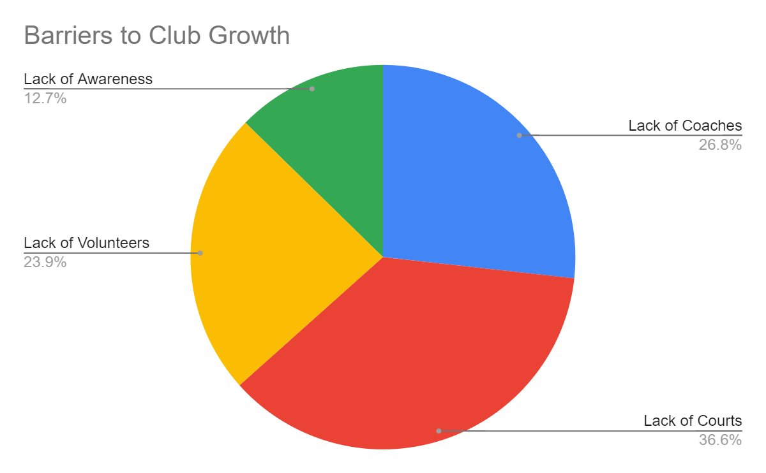
- The most heavily requested support for the next 12 months from clubs is additional funding. Greater access to coaches is also heavily requested. Raising the profile of squash at a local and national level is also a big request.
- 3 key themes emerge on the one priority items for clubs to improve playing experience in their club
  - Better courts
  - Access to coaching
  - More junior programmes
- The key themes emerging from suggesting on how to grow the sport on a national level revolve around a combination of
  - Increasing visibility (Specific campaigns, more storytelling. More media coverage)
  - Introducing squash to schools
  - Partnering with other local sports i.e Hurling (particularly for smaller clubs and those in GAA clubs and/or strongholds)
  - Providing best practice resources to clubs

Summary Note
Irish Squash has increased it’s overall membership, but there is a distinct lack of Irish Squash affiliation mirroring club membership numbers. Ulster have been a shining light in growing their clubs in 2023/24. Moreover, junior and women membership numbers are up considerably, despite many clubs citing these areas as key needs for improvement and are requesting support in this regard. From a membership perspective, it is clear that additional coaches are massively needed to appease clubs and increase playing numbers, especially across inclusion categories. Increasing visibility and introducing squash to schools is seen as a key pathway for growth by clubs. The majority of clubs are planning facility improvements, but some smaller clubs would prefer some additional hands-on support.
There are some positive highlights from many specific clubs which will be shared to portray the growth of grassroots squash.

