Table of Contents

1. Breakdown of the organisations: 1

2. Training & Assessment 3

3. Safeguarding, Garda Vetting, & refereeing information 4

4. Intro to WSF Coach philosophy: 5

5. Competency 1 – Knowledge and Understanding 6

6. Competency 2 – Skill of Delivery 8

7. Competency 3 – Lesson Planning to Effect Positive Change 13

8. Practical use of the tools 14

9. Additional resources 17

# Breakdown of the organisations:

**Who we are**

**Irish Squash** is the **National Governing Body** (NGB) for **the sport of squash in Ireland** and is officially recognized as such by Sport Ireland. It is made up of a voluntary board elected each year at an AGM.

Our Governance Documentation includes:

* [**Privacy Policy**](https://eur03.safelinks.protection.outlook.com/?url=https%3A%2F%2Fwww.irishsquash.com%2Fprivacy-policy%2F&data=04%7C01%7C%7Cc64cf50e069e46bcfe0f08d931966403%7C9d8ad7f7295f41c6b7d777af2ad17cd5%7C0%7C0%7C637595344263403027%7CUnknown%7CTWFpbGZsb3d8eyJWIjoiMC4wLjAwMDAiLCJQIjoiV2luMzIiLCJBTiI6Ik1haWwiLCJXVCI6Mn0%3D%7C1000&sdata=%2FJ2IEKUZcq3%2BugXCTTcdL0EchcnXMSo9ivBE%2F%2F6wViw%3D&reserved=0)
* [**Data Protection Compliance – 8 Steps**](https://eur03.safelinks.protection.outlook.com/?url=https%3A%2F%2Fwww.irishsquash.com%2Fdata-protection-compliance-8-steps%2F&data=04%7C01%7C%7Cc64cf50e069e46bcfe0f08d931966403%7C9d8ad7f7295f41c6b7d777af2ad17cd5%7C0%7C0%7C637595344263413016%7CUnknown%7CTWFpbGZsb3d8eyJWIjoiMC4wLjAwMDAiLCJQIjoiV2luMzIiLCJBTiI6Ik1haWwiLCJXVCI6Mn0%3D%7C1000&sdata=kII6n3loBkmtRqvUvp3x5YVzupehJwVAYo2CfItwB5M%3D&reserved=0)
* [**Volunteer Training – GDPR**](https://eur03.safelinks.protection.outlook.com/?url=https%3A%2F%2Fsquashireland.connectedrms.com%2F&data=04%7C01%7C%7Cc64cf50e069e46bcfe0f08d931966403%7C9d8ad7f7295f41c6b7d777af2ad17cd5%7C0%7C0%7C637595344263413016%7CUnknown%7CTWFpbGZsb3d8eyJWIjoiMC4wLjAwMDAiLCJQIjoiV2luMzIiLCJBTiI6Ik1haWwiLCJXVCI6Mn0%3D%7C1000&sdata=2GPLpLsmZLqMTne4%2Fjloj9sWPDSPBVwOq4s5MYZNYIg%3D&reserved=0)
* [**Garda Vetting/ Access NI Procedure**](https://eur03.safelinks.protection.outlook.com/?url=https%3A%2F%2Fwww.irishsquash.com%2Fgarda-vetting%2F&data=04%7C01%7C%7Cc64cf50e069e46bcfe0f08d931966403%7C9d8ad7f7295f41c6b7d777af2ad17cd5%7C0%7C0%7C637595344263423012%7CUnknown%7CTWFpbGZsb3d8eyJWIjoiMC4wLjAwMDAiLCJQIjoiV2luMzIiLCJBTiI6Ik1haWwiLCJXVCI6Mn0%3D%7C1000&sdata=OTieLN%2B40P3sXIEB4YSlmiYZFRFEui6IVfbEa5D34WE%3D&reserved=0)
* [**Safeguarding Children**](https://eur03.safelinks.protection.outlook.com/?url=https%3A%2F%2Fwww.irishsquash.com%2Fsafeguarding-children%2F&data=04%7C01%7C%7Cc64cf50e069e46bcfe0f08d931966403%7C9d8ad7f7295f41c6b7d777af2ad17cd5%7C0%7C0%7C637595344263423012%7CUnknown%7CTWFpbGZsb3d8eyJWIjoiMC4wLjAwMDAiLCJQIjoiV2luMzIiLCJBTiI6Ik1haWwiLCJXVCI6Mn0%3D%7C1000&sdata=PcQJna6gYGzevOBAlPGTIHal%2BPDwo4dUOkkLZUtgcm4%3D&reserved=0)
* [**Anti-Doping Guidelines**](https://eur03.safelinks.protection.outlook.com/?url=https%3A%2F%2Fwww.irishsquash.com%2Fanti-doping%2F&data=04%7C01%7C%7Cc64cf50e069e46bcfe0f08d931966403%7C9d8ad7f7295f41c6b7d777af2ad17cd5%7C0%7C0%7C637595344263433010%7CUnknown%7CTWFpbGZsb3d8eyJWIjoiMC4wLjAwMDAiLCJQIjoiV2luMzIiLCJBTiI6Ik1haWwiLCJXVCI6Mn0%3D%7C1000&sdata=OLwLLNXzLiqLMeum5GVUbKieEv%2FrzSXeCi5cJCSpmZc%3D&reserved=0)
* [**Constitution of Irish Squash Federation clg**](https://eur03.safelinks.protection.outlook.com/?url=https%3A%2F%2Fwww.irishsquash.com%2Fwp-content%2Fuploads%2F2012%2F07%2FCLG-MA-Irish-Squash-Federation-CLG.August-2015.pdf&data=04%7C01%7C%7Cc64cf50e069e46bcfe0f08d931966403%7C9d8ad7f7295f41c6b7d777af2ad17cd5%7C0%7C0%7C637595344263443010%7CUnknown%7CTWFpbGZsb3d8eyJWIjoiMC4wLjAwMDAiLCJQIjoiV2luMzIiLCJBTiI6Ik1haWwiLCJXVCI6Mn0%3D%7C1000&sdata=pqSGGU1mXyXdxI1OmShY2wlhOuq6uBXOSJmT9KAdCtU%3D&reserved=0)

The Irish Squash Federation is an All-Ireland Body encompassing the 32 counties with the four Regional Provinces being responsible for organizing Leagues and Competitions.

As a National Governing Body we proactively develop and promote squash. We offer a comprehensive range of support and services at national, regional and local levels including:

• Events and competitions for all ages and abilities

• Coach Education Programmes

• Advice on Technical and Maintenance services

• Structured Development Programmes

• Raise awareness of the sport

Irish Squash is a member of the World Federation of Squash (WSF) and the European Federation of Squash (ESF). Irish Squash is an organisation funded from the following sectors:

• Public Sector Funding (Sport Ireland)

• Membership / Affiliation Fees

• Private Sector Sponsorship

**The Irish Squash Coach developer committee consists of:**

* Kieran Doherty
* Frank Donnelly
* Elvy De Costa
* Eddie Murphy

All the above are qualified coach developers with Sport Ireland Coaching and WSF (World Squash Federation)

**Membership**

Benefits of Joining Irish Squash

* ***Help support your sport. It is only with your support that we can develop and promote the Sport***
* ***Full Personal Accident Insurance – Details from info@irishsquash.com***
* ***Public Liability Insurance for your club – Details from info@irishsquash.com***
* ***10% Discount for squash equipment on Rackets.ie – See***[*HERE*](http://rackets.ie/index.php?l=page_view&p=irish_squash)
* ***Garda Vetting Service Provided by IRISH SQUASH liaison officer FREE (Squash players/coaches cannot do this themselves). Other Sports charge for this service***
* ***Full Access to Play in Leagues and National Competitions ( League/Competition Members Only)***
* ***Access to Coaching and Referee Courses supplied by IRISH SQUASH***
* ***Apply for a Sports Capital Grant – To be eligible to apply for a Dept. of Sport, Sports Capital Grant your club needs to be affiliated to a National Governing Body (NGB)***
* ***Access to Irish international players, to run a fundraising exhibition match, for the club***
* ***Part funding to run Participation courses, aimed at 10-12yrs children to recruit them to squash and your club***
* Opportunity to apply for Sport Ireland grants e.g. Women in Sport participation grants
* ***Province can apply for a rebate of their club’s affiliation fees, of up to 40% of the total paid by the clubs***
* ***Access to qualify to represent Ireland at International Events***
* ***Access to Regional Development Officers***
* ***Receipt of Newsletter to keep you updated***

Rates

* **Adult League/Competition Member €25,**
* **Adult Recreational Member €15**
* **Associate Member (Non Playing) €10**
* **Student Member €10**
* **Junior Member €5**
* **Overseas Member €20**

**To join Irish Squash as an overseas/individual player click** [**HERE**](http://www.myclubfinances.com/memberships.asp?LL_ID=435&intMF_ID=333)

The **World Squash Federation** (WSF) is the global governing body for the sport of squash.

The WSF is a proud International Federation of approaching 150 Members and around 50,000 courts worldwide. There are also five Regional Federations under our auspices.

Squash is an ideal lifestyle sport enjoyed by recreational and competitive players around the world. We are responsible for every facet of squash development and promotion, other than the professional tours which are overseen by the Professional Squash Association (PSA).

The Federation celebrated its 50th anniversary in 2017

**World Squash Federation Mission Statement**

On behalf of our Member National Federations and other relevant stakeholders, the WSF’s mission is to:

• Provide effective leadership and collaboration for raising the visibility and profile of squash; principally via World Championships and participation in Major Games;

• Enhance the global support infrastructure for squash, including refereeing, coaching, technical expertise and event management; ensuring squash remains a clean sport – and the encouragement of grass-roots development and participation particularly within emerging squash nations;

• Responsibly direct squash’s future as a globally recognised and respected mainstream sport.

The WSF is recognised by the International Olympic Committee as the International Federation for squash and is a member of the General Association of International Sports Federations and of the Association of the IOC Recognised International Sports Federations.

**Membership**

The WSF has nearly 150 Members, all of whom are National Federations of squash, recognised by their National Olympic Committee or Ministry of Sport as the sole recognised governing body for the sport in their country. Members are required to join one of the five Regional Federations which are an integral part of our structure. Each Member is allocated votes to be used at General Meetings based on the number of squash courts in their country.

**What we do**

Provide a process for Irish squash and WSF Coach Developers to train candidate coaches to coach squash to a recognised level of competency

**What you will be able to do**

The Level 1 WSF Coach is to introduce squash to people at grassroots level which includes clubs, colleges, schools, GAA clubs and leisure centres.

# Training & Assessment

**What you need to know when becoming a Level 1 WSF Coach:**

You must be a registered member of Irish squash

Before you attend the course you are required to register with WSF for a spin number, this number will be unique to you.

You need to be Garda vetted and you must also attend a Safe guarding course and provide a certificate.

* **Safeguarding:** www.irishsquash.ie/
* **Garda Vetting:** www.irishsquash.ie/
* **Disability/Inclusion Policy:** <https://www.sportireland.ie/sites/default/files/2019-12/sport-ireland-policy-on-participation-in-sport-by-people-with-disabilities.pdf>
* **WSF membership SPIN:** <http://www.worldsquash.org/spins/>
* **Irish Squash membership:** <https://www.irishsquash.com/membership-2/>

**Who to contact:**

Paul Nugent COO – Chief Operations Officer in Irish Squash Head office for payment

[info@irishsquash.com](mailto:info@irishsquash.com) or Tel: +353-1-6251145

Garda vetting link is hosted on the Irish Squash web site

**Two** documents are required:

1. [**Irish Squash Vetting Invitation NVB1**](https://www.irishsquash.com/wp-content/uploads/2018/07/Irish-Squash-Vetting-Invitation-NVB1-June-2018.pdf)
2. [**Irish Squash Vetting ID Verification Form**](https://www.irishsquash.com/wp-content/uploads/2021/03/Irish-Squash-Vetting-ID-Verification-form-v1.3.pdf)

Both forms must be **printed** off, **completed** and **posted** together with any additional required documentation to:

Gerry Connaughton  
Irish Squash Liaison Person  
76 Caiseal Na Rí  
Cashel  
County Tipperary  
E25 TD50

**WSF Level 1 Course details**:

Course is run over 2 weekends, the 1st 3.5 days you will be on court and in the class room with the Tutor gaining experience in creating and executing lesson plans, demonstrating how to play the various squash shots, using tools, with the WSF Coaching Philosophy.

The Final half a day will be set aside for an Independent Assessor to come and assess the lesson plans that each candidate was assigned the night before.

**Links to help you design sessions plans:**

**Videos for Level 1 WSF coaching course:** <http://www.worldsquash.org/26434-2/>

**Assessment**

**The assessment takes three parts:**

* Brief **Written Lesson Plan** on a given topic to deliver in real time between 20 & 30 minutes
* **Skill of Delivery** of the safe practical delivery of individual and / or group lesson
* **A Question and Answer** session with the tutor / assessor based on the course syllabus

Debrief assessments and review course.

**What to do after assessment?**

# Safeguarding, Garda Vetting, & refereeing information

Below are essentials for every level 1 WSF coach to have:

**Safeguarding:** [www.irishsquash.ie/](http://www.irishsquash.ie/)

**Garda Vetting:** [www.irishsquash.ie/](http://www.irishsquash.ie/)

**Disability/Inclusion Policy:** <https://www.sportireland.ie/sites/default/files/2019-12/sport-ireland-policy-on-participation-in-sport-by-people-with-disabilities.pdf>

**WSF membership SPIN:** <http://www.worldsquash.org/spins/>

**Irish Squash membership:** <https://www.irishsquash.com/membership-2/>

**Links to help you design sessions plans:**

**Videos for Level 1 WSF coaching course:** <http://www.worldsquash.org/26434-2/>

**Helpful links for when you have questions:**

Irish Squash: Coaching Secretary – Eddie Murphy – [coachingsecretary@irishsquash.ie](mailto:coachingsecretary@irishsquash.ie)

Irish Squash: Chief Operations Officer – Paul Nugent – [paul.nugent@irishsquash.ie](mailto:paul.nugent@irishsquash.ie)

European Squash – European Squash Administrator- Michael Kahn – [Michael.kahn@europeansquash.com](mailto:Michael.kahn@europeansquash.com)

World Squash Federation: Direct admin queries – [admin@worldsquash.org](mailto:admin@worldsquash.org) or [www.worldsquash.com](http://www.worldsquash.com)

**Refereeing Links to World Squash Officiating**

https://worldsquashofficiating.com/

# Intro to WSF Coach philosophy:

Below headings are the backbone of the WSF coaching philosophy. For more information on these headings go to <https://www.worldsquash.org/26434-2/>

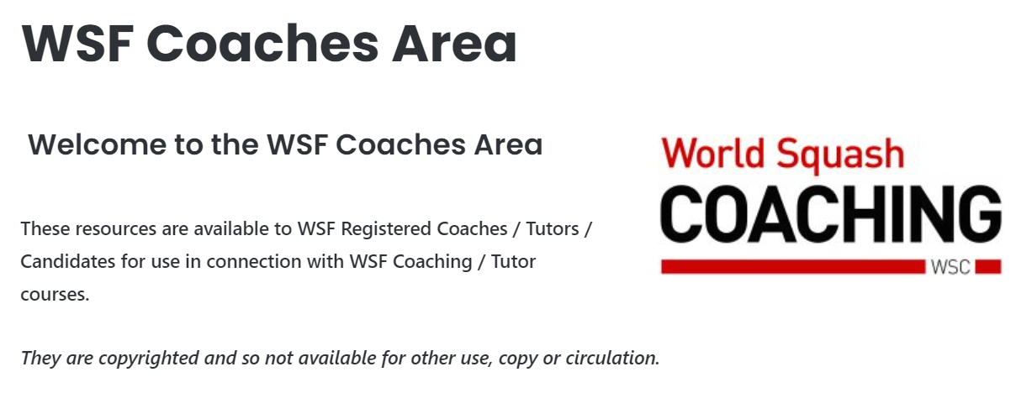

There are videos, podcasts and images to help support you through your coaching experience.

* How Squash is judged
* Open skill = Perception – Decision – Action (PDA)
* Process – LTPD – Biological windows – Neurological pathways
* Based on Knowledge of how squash is played – Skill of Delivery of passing information – Lesson Planning = Process & use of **TOOLS** of **HOW** to coach

**LTPAD/LISPA:**

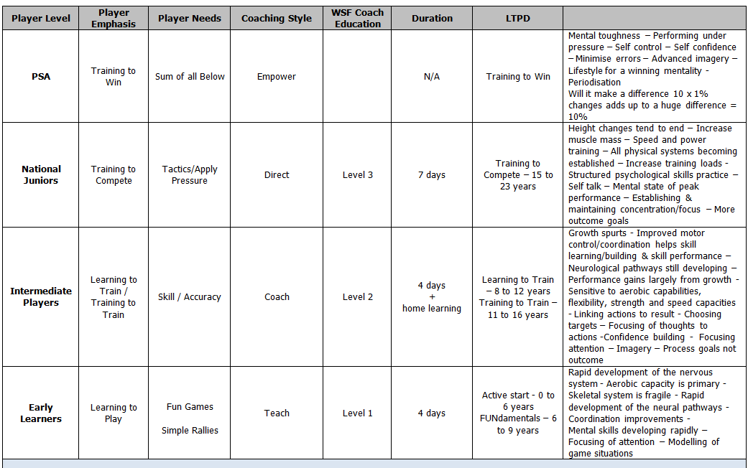

* **Learning to Play** – Simple Rallies - WSF Level 1 syllabus
* **Learning to Train** – Skill / Accuracy – WSF Level 2 syllabus
* **Training to Compete** – Tactics / Apply Pressure – WSF Level 3 syllabus
* **Training to Win** – Sum of all the above

# Competency 1 – Knowledge and Understanding

At the end of this module coaches will be able to:

1. Relate to other coaches and tutors on the course
2. Self -reflect as a coach
3. Understand the role of a WSF Level 1 coach within the WSF coaching Programme
4. Understand the coaching process of Learning to Play - Simple Rallies – PDA cycle – for squash
5. Understand the purpose of Generic Skills
6. Understand the purpose of Long Term Player Development
7. Understand the use of Coaching Tools – PDA cycle for coaching Simple Rallies in squash
8. Describe the use of Tools and how they are used to effect positive change for early learner players

**How to work with FUNdementals:**

All sports are built on the practical application of Generic Movement Skills

* ABCS
* Agility
* Balance
* Coordination
* Speed/Strength/Stamina

**Agility – Balance – Coordination – Speed**

Practical examples of Agility:

* Agility ladder: Hop on 1 leg into every hole - Other leg - Jumping forwards - Jumping backwards
* Tag game: 1-6 Players per court, 1 Player starts – touches another player who becomes the Tag
* Practical examples of Balance: Stand on BOSU ball - Jump on to BOSU ball – balance and jump off - Shadow play into 4 corner jumping onto BOSU ball on the T-zone between each corner
* Practical examples of coordination: Slalom running between cones - Slalom running to 4 corners
* Practical examples of Speed: Half court sprints – playing hand to touch the floor at the turn - Quick start to catch a ball thrown by the coach - Team race – full court sprints from different start postures e.g. bridge – sitting – laying – backwards sitting
* Practical examples of stamina: Pyramid running on court - Side stepping to side wall and jump as high as possible to touch the wall - Side stepping and bridge
* Practical examples of suppleness: - In pairs, sitting with feet apart and soles touching – hold partners hands and pull gently backwards and forwards - In pairs, stand side by side holding hands above the head and bend from side to side - In pairs, 1 sitting with legs straight – partner gently pushes forwards slowly below the shoulder blades – ensure back stays straight
* 5.2. Kinaesthetic Awareness – Gliding
* Practical examples of Kinaesthetic Awareness: Shadow play to all 4 corners - Shadow play in the 2 front corners with a small weight in each hand
* Practical examples of gliding: Split step and move to front corners – playing hand to touch the floor

**Catching – Passing – Striking**

* Practical examples of catching –
* In pairs - A rolls the ball to B who using both hands, catches the ball and rolls it back to A - Progresses as above catching with one hand - A throws the ball underarm to B who catches with both hands and throws it back –
* As above catching with one hand
* Side-arm throw –
* Key issue for early learners - Over-arm throw and have the group read / predict as early as possible which of the four actions will occur.
* Practical examples of passing: In small groups form a circle – slowly throw the ball under-arm randomly to any other member of the circle to catch with both hands - As above catching with one hand
* Practical examples of striking:
* From a stationary position using the FH side of a racket try to keep a ball stationary – progressing to rolling the ball around the racket clockwise / anti-clockwise – progressing to a low bounce no higher than their nose! - Progress to walking around with a low bounce -
* Progressing to around cones placed 1 metre apart - Progressing to relay races in teams - Progressing to: Linking Throwing to Striking to Passing to Catching: -
* A throws the ball under-arm to B who strikes the ball for B to catch – progressing to: - In small groups in a circle randomly passing the ball by striking to other members in the circle
* All Squash modified games e.g. ‘Big Hand’ – ‘Mini Squash’ – ‘EzeeBat’ - ‘Racquetball’ all apply extremely well for early learners

**IDEAS**  - Stands for :

* **I**ntroduction
* **D**emonstration
* **E**xplanation
* **A**ctivity
* **S**ummary

When you are delivering a topic using the ‘WHAT, WHY WHEN AND HOW’ method you can also use IDEAS as a method of delivery

# Competency 2 – Skill of Delivery

 By the end of this module, coaches will be able to demonstrate that they can:

* Understand HOW to relate to early learner squash players
* Understand different learning styles of players and the need for different coaching styles
* Understand the key principles of Introduction and Demonstration
* Demonstrate and introduce the key principles of WWWH to the grip
* Warm Ups
* Demonstrate and introduce the key principle of WWWH to service, drives, boasts, drops and volleys into simple rallies progressively
* Understand and demonstrate the patterns of movement within simple Open Skill rallies in squash
* Safety on Court
* Demonstrations
* Observe, diagnose faults and provide feedback to progress performance of simple rallies – PRACTICAL USE OF THE TOOLS

**On Court:**

**Safety & Risk assessments**

**List of Do’s and Don’ts**

**Individual**:

Condition of court – slippery floor, loose boards etc – could a player fall and hurt themselves?

Playing equipment – are shoes and racket in good condition? Are they wearing appropriate clothing?

Regular drink breaks taken

Player medical history – any pre-existing medical conditions? How hard could they be pushed? Are there certain things we should avoid during the particular session? Would the coach always make extensive enquiries about a junior in order to avoid conditions like Osgood schlatters”

Wearing WSF Certified Protective Eyewear for juniors is mandatory

Contact mobile for parents – just in case!

Club to have a first aid kit

Coach to have some basic first aid training

**Group**:

All the above

For groups get parents to sign a consent form that provides all background info.

Wearing WSF Certified Protective Eyewear for juniors is mandatory

Stress the use of a safe swing.

Players to stop immediately if coach yells “time” or “stop” - vital, if there is more than one ball being used on court .

**Skills of delivery - class**

1. Understand **HOW** to relate to early learner squash players

2. Understand different learning styles of players and the need for different coaching styles

3. Understand the key principles of **Introduction and Demonstration**

4. Demonstrate and introduce the key principles of **WWWH** (What, Why When, How) to the grip

5. Warm Ups

6. Demonstrate and introduce the key principle of **WWWH** to service, drives, boasts, drops and volleys into simple rallies progressively

7. Understand and demonstrate the patterns of movement within simple **Open Skill** rallies in squash

8. Safety on Court

9. Demonstrations

10. Observe, diagnose faults and provide feedback to progress performance of simple rallies –

**PRACTICAL USE OF THE TOOLS**

**WWWH - What, when, why, how – IDEAS:**

What does the player want to be able to do?

Why it is important that they can do it?

When would it be appropriate to do it?

How it could be achieved?

**Lesson Planning**

* All lessons will include:
* Warm up
* Process of Assessment of the Players – The Clock – PDA –
* Find problem areas
* Diagnosis – Prioritise what is causing the problem - Likely issues
* Demonstration of Skill being introduced – Show / Tell / Try –
* IDEAS – Introduction/Demonstration/Explanation/Action/Summary
* Highlight a single area for the player to focus attention on to improve
* Let them try – Closed skill progressing to Open Skill – Up or
  + down – 0-100 – When Problems do less!
* Skills practice
* Games - Modified / Conditioned / Fun Competition practice if appropriate
* Cool down
* Summing up lesson / Closure

**Demonstration Principals**

**SHOW -** with a partner helper in a rally situation briefly show the skill being demonstrated to create a visual image

**TELL -** briefly explain the key issues around PDA

**SHOW AGAIN -** whilst highlighting the key issues, progressively drawing the groups attention verbally at the same time.

**TRY -** organise the group to practice the skill of performing a good demonstration

**Demonstration Warm Up**

**WHAT -** Warm up is the process by which we prepare the Body and Mind to practice and or play squash.

**WHY** - Prevents injuries – allows everything to work at full speed

**WHEN -** Before training – practice – competition

**HOW -** Jogging / Stretching / Shadow play / Striking

**Demonstration Lifting Drive Length**

**WHAT -** Strike the ball to first hit the front wall mid-way above the service line and the outline – to then travel as close to the side wall as possible – bounce on the floor just behind the service box

**WHY -** To try to force your opponent into a back corner away from the T-zone

**WHEN -** Your opponent is on the T-zone or in front of you

**HOW -** P - Focus on your partner’s actions when your partner is striking the ball

D - Decide where you want to time the ball (i.e. make contact with the ball) and the target to length

A - Moving from the T-Zone into a position facing the side wall with the racket up. The racket begins to move down and forward to a point of contact at George with a loose Grip following through on the recovery back to the T-zone

**Demonstration Drop**

**WHAT-** You want the ball to do – strike the ball to hit low on the front wall, to then bounce on the floor close to the wall

**WHY -** To push partner to the front corner of the court

**WHEN -** Your partner is behind

**HOW -**P - Focus on your partners actions when your partner is striking the ball

D - Decide where you want to time the ball (i.e. make contact with the ball – preferably early on the volley) and the target short to strike the front wall half way between the Tin and the service line

A - Moving from the T-Zone into a position facing the side wall with the racket up. The racket begins to move down and forward to a point of contact with a loose Grip following through, recovering back to the T-zone

**Demonstration 3 Wall Boast**

**WHAT -** Strike the ball to hit the side-wall – front wall near the service-line – the opposite side-wall to then bounce on the floor having lost pace at the front part of the court.

**Why -** To force partner to move away from the T-zone

**WHEN -** Ball has gone past player’s body OR is not looking.

**HOW -** P - Focus on your partner’s body actions and their racket actions when they are striking the ball

D - Decide where you want to time the ball (i.e. make contact with the ball) and the target diagonally at the front of the court

A - Moving from the T-Zone into a position facing the nearest back corner. The racket moves forward and with a lifting movement to a point of contact at George with a loose Grip following through on the recovery back to the T-zone.

**Demonstration Cross- Court Drive / Length**

**WHAT -** Aim to hit the front wall just off-centre – side wall at the back of the service box

**WHY -** To move your partner away from the T-Zone

**WHEN -** Your partner is at the front or the other side of the court

**HOW -** P - Focus on your partners body actions and their racket actions when they are striking the ball to try and predict where the ball will travel

D - Decide where you want to time the ball during its flight and the target on the side wall

A - Moving from the T-Zone into a position facing the nearest front corner. The racket moves forward and with a lifting movement to a point of contact at George with a loose Grip following through on the recovery back to the T-zone

**Demonstration Service**

**WHAT -** The ball must strike the front wall between the service and out lines to bounce in the opposite back court behind the short line – this can be the same as a lob or drive to length

**WHY -** To put the ball in play and put the opponent under pressure

**WHEN -** The start of every rally

**HOW -** With a foot in a service box with your free hand throw the ball to a position that is favourable to you and strike

**Straight Volley Return of Service:**

**WHAT -** To strike the ball at a high point before it bounces to first hit the front wall mid way above the service line and the outline – to then travel as close to the side wall as possible – and to bounce on the floor behind the service box

**WHY -** To try to force the opponent into a back corner away from the T-zone

**WHEN** - Your opponent is on the T-zone or in front of you

**HOW -** P - Focus on your partners’ service action when they strike the ball

D – Making your decision to strike the ball on the volley before it drops to the ground

A – Moving from the T-zone into a position facing the side wall with the racket high, moving forward to strike the ball at the highest level possible with a loose grip, short action and recovering back to the T-zone.

**Diagnostic Clock**

**WHAT -** The PDA when used as a clock is a diagnostic tool to highlight areas of development for early learner players

**WHY -** It provides the coach with a process / procedure in context and chronological sequence of the elements of open rallies in squash

**WHEN -** The early learner player has difficulty in progressing a skill

**HOW -** Search starting at 12 to 1,2,3,4 etc. through to 12 – Work on the small numbers first through to 12.

Using the Tools as areas of focus to assist progression and development.

# Competency 3 – Lesson Planning to Effect Positive Change

Learning outcomes: by the end of this module, coaches will be able to demonstrate that they can:

* Understand and describe the differences between coaching an individual and groups
* Plan and deliver a series of individual lessons to develop simple rallies for squash, observing, diagnosing areas for improvement and providing feedback to improve positive change
* Plan and deliver a series of group lessons of modified fun games and a simple rally situation for squash, observing, diagnosing areas for improvement and providing feedback to improve positive change.
* Understand and describe the differences between coaching an individual and groups
* Plan and deliver a progressive series of individual lessons to develop simple rallies; observing, diagnosing areas for improvement and providing feedback to improve positive change
* Plan and deliver a progressive series of group lessons of modified fun games and simple rally situations; observing, diagnosing areas for improvement and providing feedback to improve positive change

# Practical use of the tools

Explaining the **TOOLS**

**Demonstrating the basic shots involved in squash.**

**Grip:**

**What** – Controls the angle, direction and speed of the racket head

**Why** – The angle and direction of the racket head controls the trajectory – speed – accuracy of the ball

**When** – All the time

**How** – By gripping the racket handle with the forefinger and thumb in a ‘V’ shape higher on the handle than the three remaining fingers – so that the handle is loosely cupped in the three remaining fingers.

Coach Developer selects someone who has experienced problems and demonstrates HOW to achieve success by only offering limited information – Holding the racket with only the Thumb & 2 Fingers – Progressing to 3 fingers, as the control level improves, keeping the smallest finger off the handle

The Coach Developer allows the player to play **SOLO** from a position 1.5 metres from the front wall

The Coach Developer stays quiet offering **NO** information

When the Coach Developer sees the player can have some small success he invites the player to progressively move to **2**

**George:**

Coach Developer introduces: ‘**‘George’’**

**What** – The natural height and distance in relation to the body for the racket hand on impact with the ball

**Why** – Helps coordination of the body movement to the moving ball

**When** – All the time out of choice

**How** – To establish ‘George’ for course candidates is to hold the racket in the non-playing hand using the grip as listed above – Using the BH side gently bounce the ball to maximum head height – Have the candidates establish how high in relation to the body is the point of contact – Change to the FH side and repeat the task

**N.B. Ensure that the point of contact stays at the same height which will then establish the natural distance of point of contact in relation to the body -** Links to the **Radar**

**Radar:**

**What** - Tracks the position of the ball in relation to body

**Why** – Helps coordination of the body movement to the moving ball

**When** – All the time

**How** – Point to the ball with the free hand

Practical

Coach Developer then asks the player to still hold with 2 Fingers and the Thumb and now place 1 finger from the non-playing hand on their wrist of their playing arm and repeat the exercise

Change partners and repeat the exercise

Progress with the 1 finger of the non playing hand gradually moving away from the playing hand but still pointing to the ball

Progress up and down observing the **Tools** turning into **Fun Games**

**Relaxed Rhythm:**

**What** – Tool that encourages the early learner to relax both grip and their whole body

**Why** – To release the body of excessive tension

**When** – Either moving into position or striking the ball

**How** – Make it a focus of attention and experience the difference

Continue to progress the above drill

**Action to result:**

**What –** Links the racket action to where the ball travels

**Why -** Allows the player to determine where ball travels with accuracy

**When –** All the time

**How –** By changing the action the ball goes to a different target

Tutor progresses the above drill to now move forward to close to the front wall and progressively back – i.e. 1 Strike - 1 Step -1 Strike -1 Step Progressively backwards and then progressively forwards etc.

**The Clock:**

**What** – Diagnostic tool to identify what are likely causes of skill based problems

**Why** – It is a systematic and accurate way to find underlying issues

**When** – All the time

**How** – Under the headings of Perception @ 12 o’clock – Decision @ 4pm – Action @ 8pm. Starting @ 12 look to see if the player is reading the opponents actions and the ball / @ 4pm onwards look to see if they are choosing a good striking position / and 8pm onwards looking to see if the player is developing a good striking action.

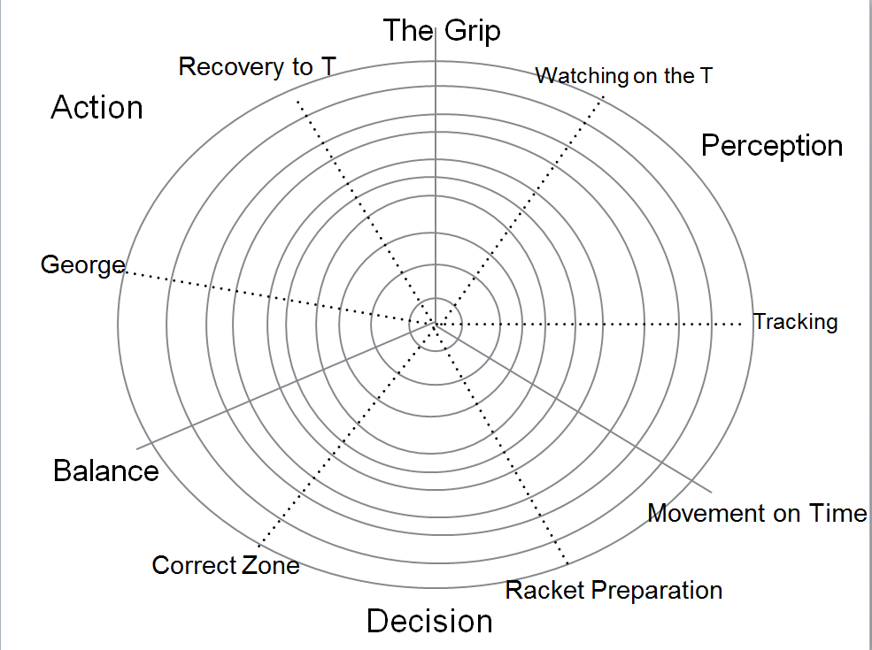Coach Developer progresses the same drill

**0 to 100:**

**What –** A measure of a player’s level of competency – judged **NOT BY STYLE** but by a level of accuracy of what the player makes the ball do!

**Why –** Sets a level of success and work level for optimal learning

**When –** All the time

**How –** Observation of the success level in a routine/drill – success rate of 9 or 10 out of 10 successes then the drill is too easy – less than 4 out of 10 is too difficult – range of 5 to 8 out of 10 is good

**Practical**

Progress the drill either up or down for the early learners to be practising between 5 and8.

**Spiders Web:**

**What** – Tool that shows the process of progressive skill building from Closed skills **to** Open

**Why** – Allows players to learn **Simple Rallies** at their own rate progressively

**When** – All the time

**How** – **PDA** - Be **Explicit** not implicit on the 3 areas of focus

**Show & Test:**

**What** – Tool that shows the differences in racket actions that makes the ball go to different targets

**Why** – Enables the player to recognise the signals of where the opponent is going to strike the ball

**When** – Focus on **opponent just before they strike the ball**

**How – PDA –** Highlight the process of **PDA** i.e. The focus of the different racket actions required to make the ball travel to different targets (**Perception**) – To recognise when is good opportunity (**Decision**).

# Additional resources

Sample: Session planner

Sample: Codes of conduct: Athletes

Sample: Codes of conduct: Coaches

Sample: Risk Assessments

Sample: Club Course application form

Sample: Terms and Conditions